DAY 6- LAB PROGRAMMING DAA

1. Bellman-Ford Algorithm
Aim
To implement the Bellman-Ford Algorithm to find the shortest distance from a given source vertex to all other vertices in a weighted directed graph and detect the presence of a negative weight cycle.
Algorithm
- Start the program.
- Initialize the distance of all vertices to infinity and set the source vertex distance to 0.
- Repeat the following steps V − 1 times, where V is the number of vertices:
  - For every edge (u, v, weight), check whether distance[u] + weight < distance[v].
  - If true, update distance[v] = distance[u] + weight.
- After V − 1 iterations, check all edges once again.
- If any distance can still be reduced, a negative weight cycle exists.
- Otherwise, display the shortest distance from the source vertex to every vertex.
- Stop the program
PROGRAM & OUTPUT
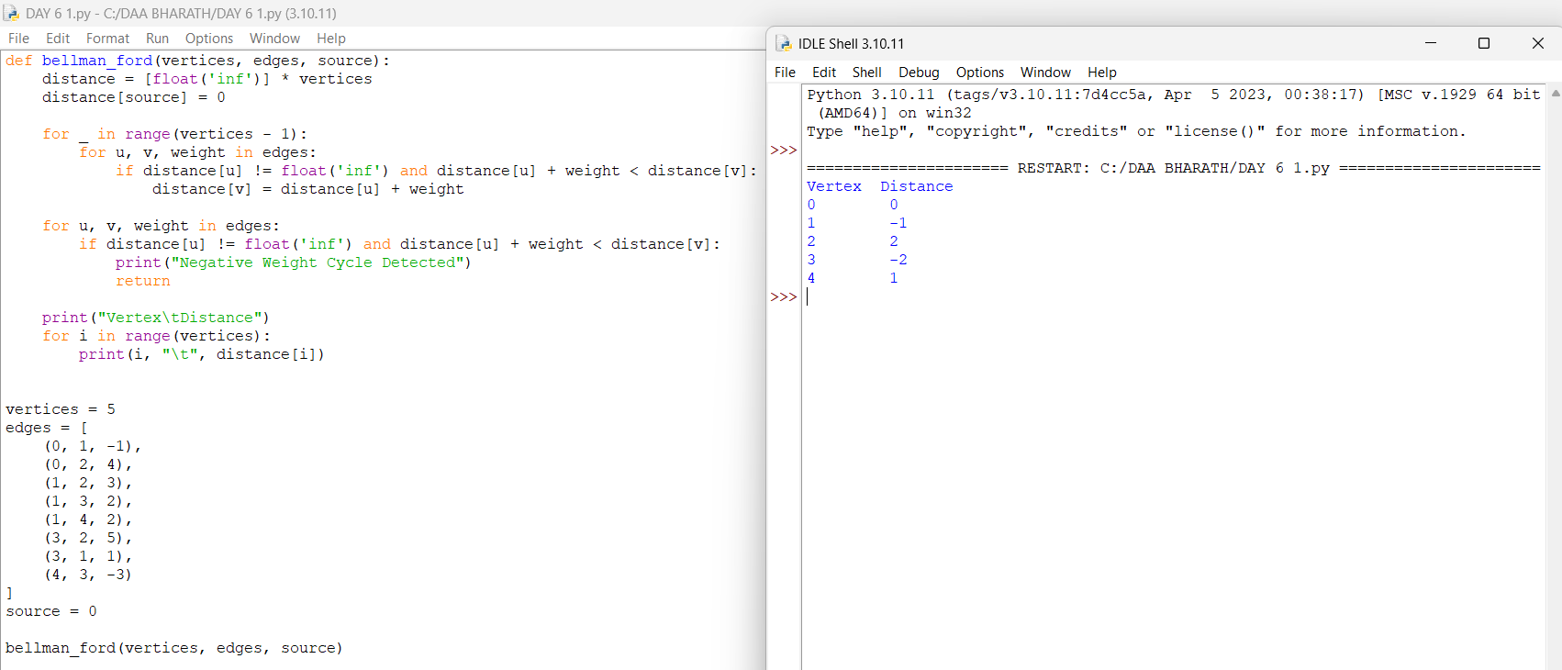
2. Floyd-Warshall Algorithm
Aim
To implement the Floyd-Warshall Algorithm to find the shortest distances between every pair of vertices in a weighted graph represented using an adjacency matrix.
Algorithm
- Start the program.
- Initialize the given adjacency matrix as the distance matrix.
- Consider each vertex as an intermediate vertex one by one.
- For every pair of vertices i and j, check whether the path through the intermediate vertex k is shorter.
- Update the distance using:
distance[i][j] = min(distance[i][j], distance[i][k] + distance[k][j]).
- Repeat the process for all vertices.
- Display the final matrix containing the shortest distances between every pair of vertices.
Time Complexity: O(V³)
Space Complexity: O(V²)
PROGRAM & OUTPUT
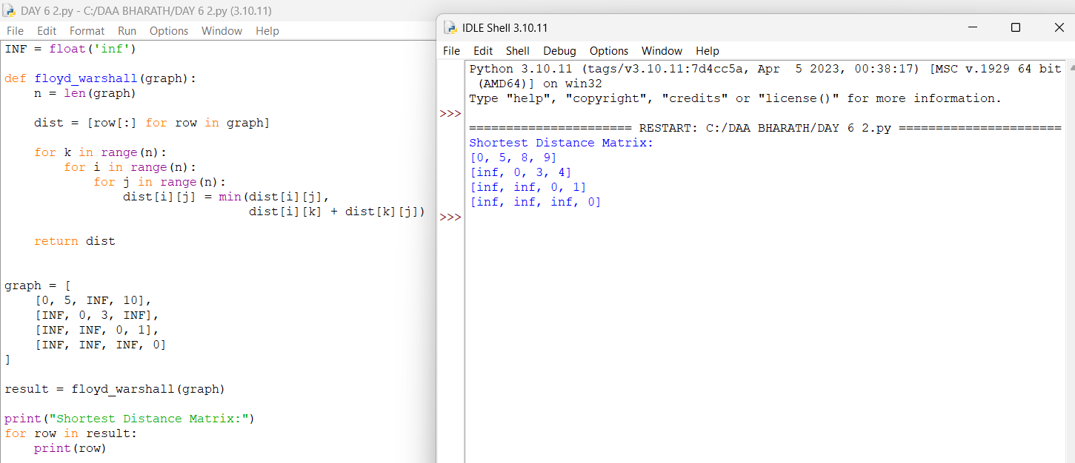

3. Warshall's Algorithm
Aim
To implement Warshall's Algorithm to find the transitive closure of a directed graph and determine whether a path exists between every pair of vertices.
Algorithm
- Start the program.
- Initialize the given adjacency matrix as the reachability matrix.
- Consider each vertex as an intermediate vertex one by one.
- For every pair of vertices i and j, check whether vertex j is reachable from vertex i through vertex k.
- Update the matrix using:
reach[i][j] = reach[i][j] OR (reach[i][k] AND reach[k][j]).
- Repeat the process for all vertices.
- Display the final matrix as the transitive closure of the graph.
Time Complexity: O(V³)
Space Complexity: O(V²)
PROGRAM & OUTPUT
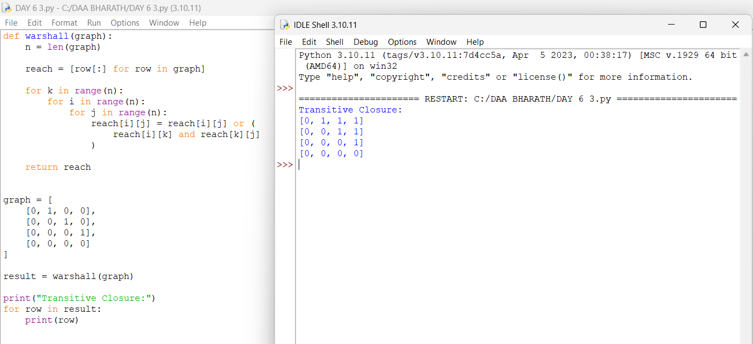

4. Find the City with the Smallest Number of Reachable Cities
Aim
To find the city that can reach the smallest number of other cities within a given distance threshold using the Floyd-Warshall Algorithm.
Algorithm
- Start the program.
- Initialize the distance matrix with infinity and set the distance from each city to itself as 0.
- Store the given edge weights in the distance matrix.
- Apply the Floyd-Warshall algorithm to find the shortest distance between every pair of cities.
- For each city, count the number of other cities whose shortest distance is less than or equal to the given threshold.
- Select the city with the smallest number of reachable cities.
- If there is a tie, select the city with the greater city number.
- Display the selected city.
PROGRAM & OUTPUT
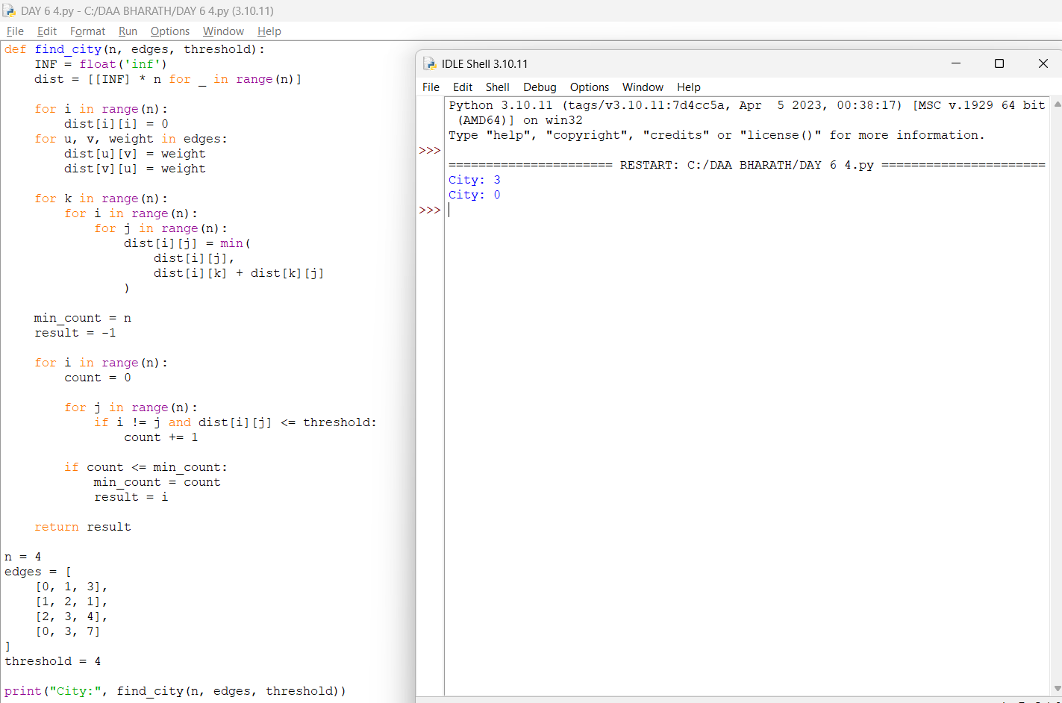
5. Network Delay Time
Aim
To find the minimum time required for a signal to reach all nodes in a network using the Bellman-Ford Algorithm, and return -1 if some nodes cannot be reached.
Algorithm
- Start the program.
- Initialize the distance of all nodes to infinity.
- Set the distance of the source node k to 0.
- Relax all edges n − 1 times using the Bellman-Ford algorithm.
- Find the maximum shortest distance among all nodes.
- If any node still has an infinite distance, return -1.
- Otherwise, return the maximum distance as the network delay time.
- Stop the program.
PROGRAM & OUTPUT
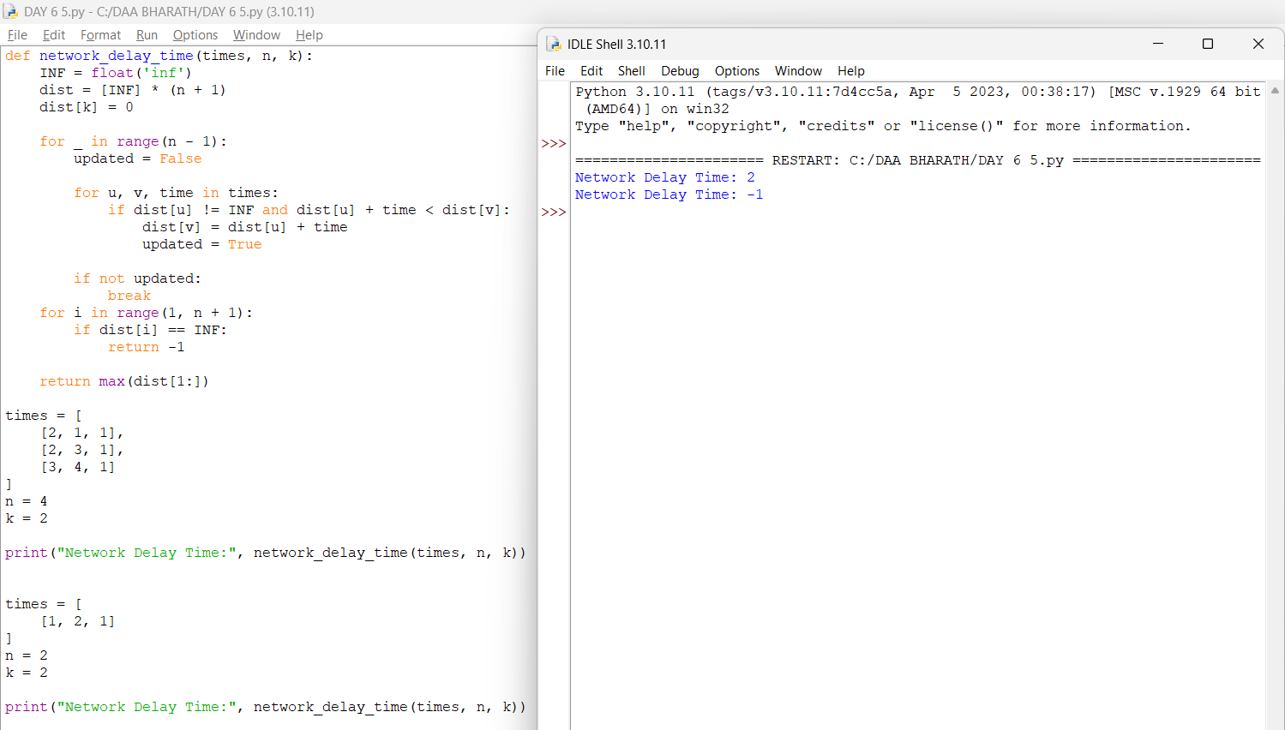

6. Cheapest Flight Within K Stops
Aim
To find the minimum cost flight from a source city to a destination city with at most K stops using the Bellman-Ford Algorithm.
Algorithm
- Start the program.
- Initialize the distance of all cities to infinity.
- Set the distance of the source city to 0.
- Relax all flights for K + 1 iterations.
- Use a temporary copy of the distance array during each iteration to avoid using more than the allowed number of stops.
- Update the cost if a cheaper route is found.
- After K + 1 iterations, check the distance of the destination city.
- Display the minimum cost. If the destination cannot be reached, display -1.
PROGRAM & OUTPUT
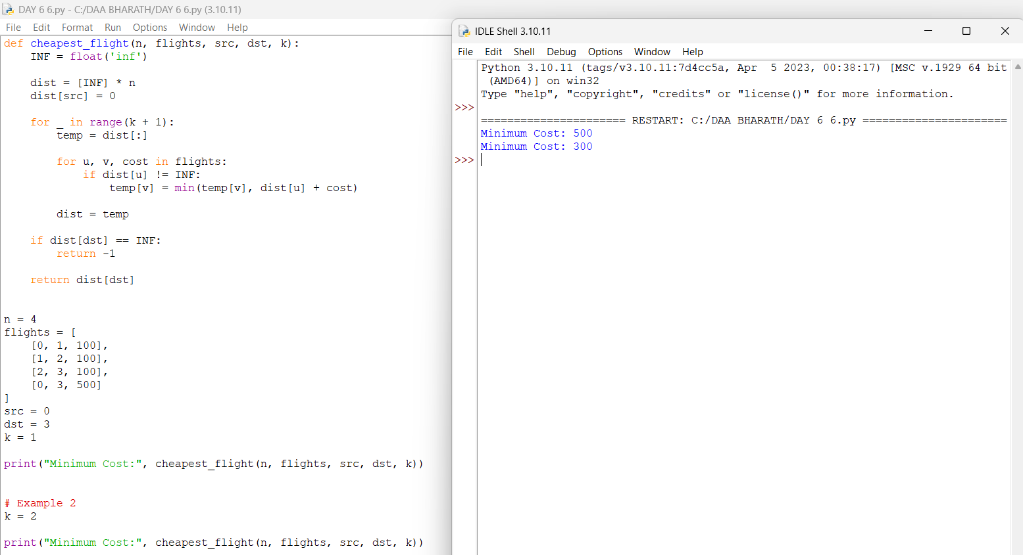

7. Detect Negative Weight Cycle
Aim
To implement the Bellman-Ford Algorithm to detect whether a weighted directed graph contains a negative weight cycle.
Algorithm
- Start the program.
- Initialize the distance of all vertices to 0.
- Relax all edges V − 1 times, where V is the number of vertices.
- Perform one additional iteration over all edges.
- If any distance can still be reduced, a negative weight cycle exists.
- Otherwise, conclude that there is no negative weight cycle.
- Display the result.
- Stop the program.
PROGRAM & OUTPUT
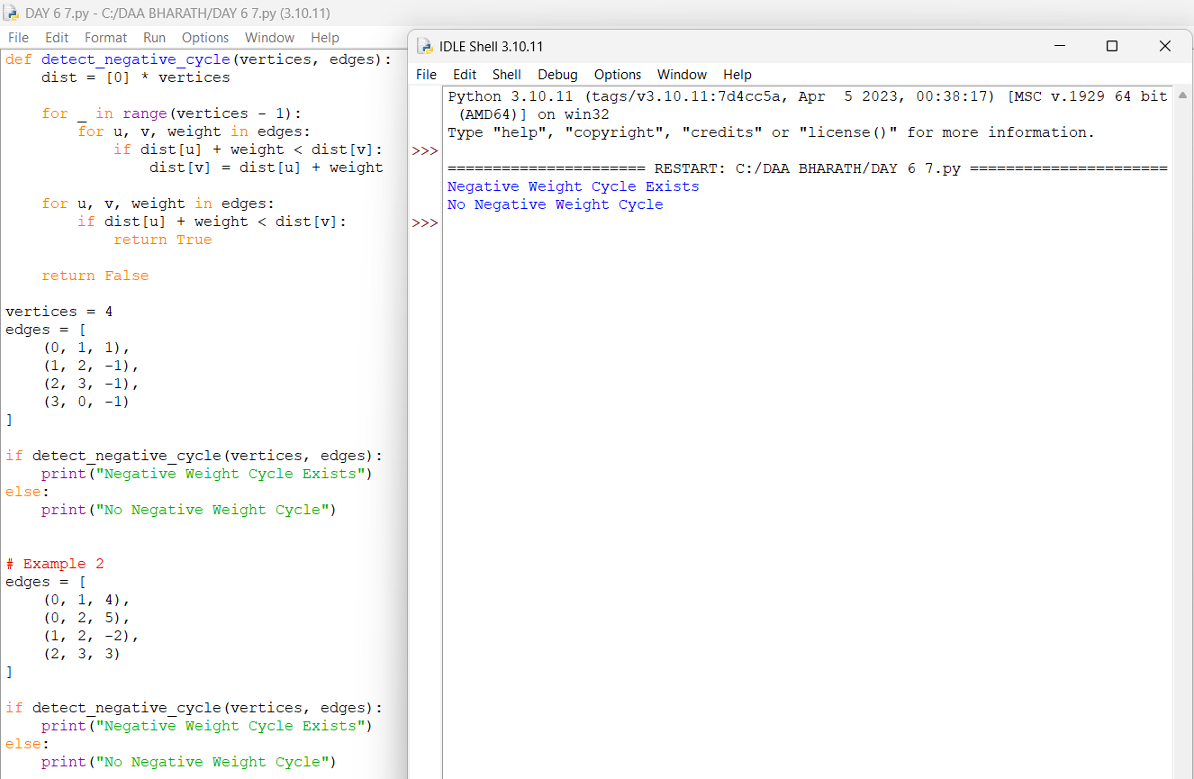

8. Determine Reachability Between Two Vertices
Aim
To determine whether a path exists between two given vertices in a directed graph using Warshall's Algorithm.
Algorithm
- Start the program.
- Read the adjacency matrix of the directed graph.
- Initialize the reachability matrix with the given adjacency matrix.
- Consider each vertex k as an intermediate vertex.
- For every pair of vertices i and j, update:
reach[i][j] = reach[i][j] OR (reach[i][k] AND reach[k][j]).
- Repeat the process for all vertices.
- Check reach[u][v].
- If it is 1, print Path Exists; otherwise, print Path Does Not Exist.
PROGRAM & OUTPUT
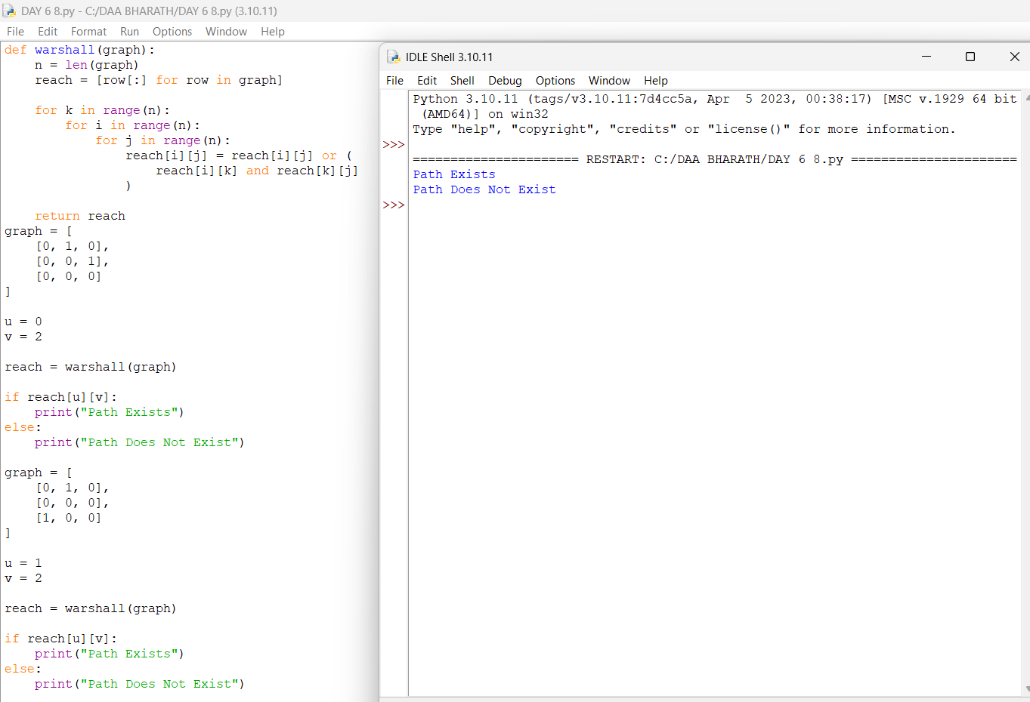

9. Count Reachable Vertices from a Source
Aim
To find the number of vertices reachable from a given source vertex in a directed graph using the transitive closure generated by Warshall's Algorithm.
Algorithm
- Start the program.
- Read the adjacency matrix and source vertex.
- Initialize the reachability matrix with the adjacency matrix.
- Apply Warshall's Algorithm to calculate the transitive closure.
- Check every vertex in the source row of the reachability matrix.
- Count the vertices whose value is 1.
- Do not count the source vertex itself.
- Display the total number of reachable vertices.
- Stop the program.
PROGRAM & OUTPUT
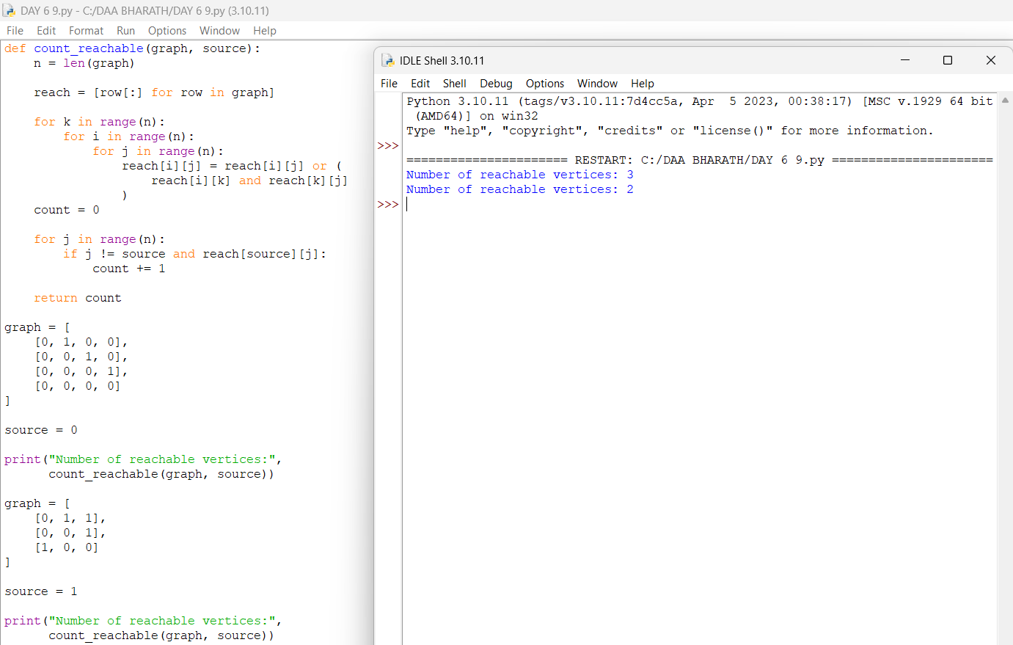

10. Find the Diameter of a Graph
Aim
To find the diameter of a weighted graph, which is the maximum shortest-path distance between any pair of vertices, using the Floyd-Warshall Algorithm.
Algorithm
- Start the program.
- Initialize the distance matrix with the given graph.
- Consider every vertex as an intermediate vertex.
- Apply the Floyd-Warshall formula to find the shortest distance between every pair of vertices.
- Find the maximum finite shortest-path distance in the resulting matrix.
- Display this maximum distance as the diameter of the graph.
- Stop the program.
PROGRAM & OUTPUT
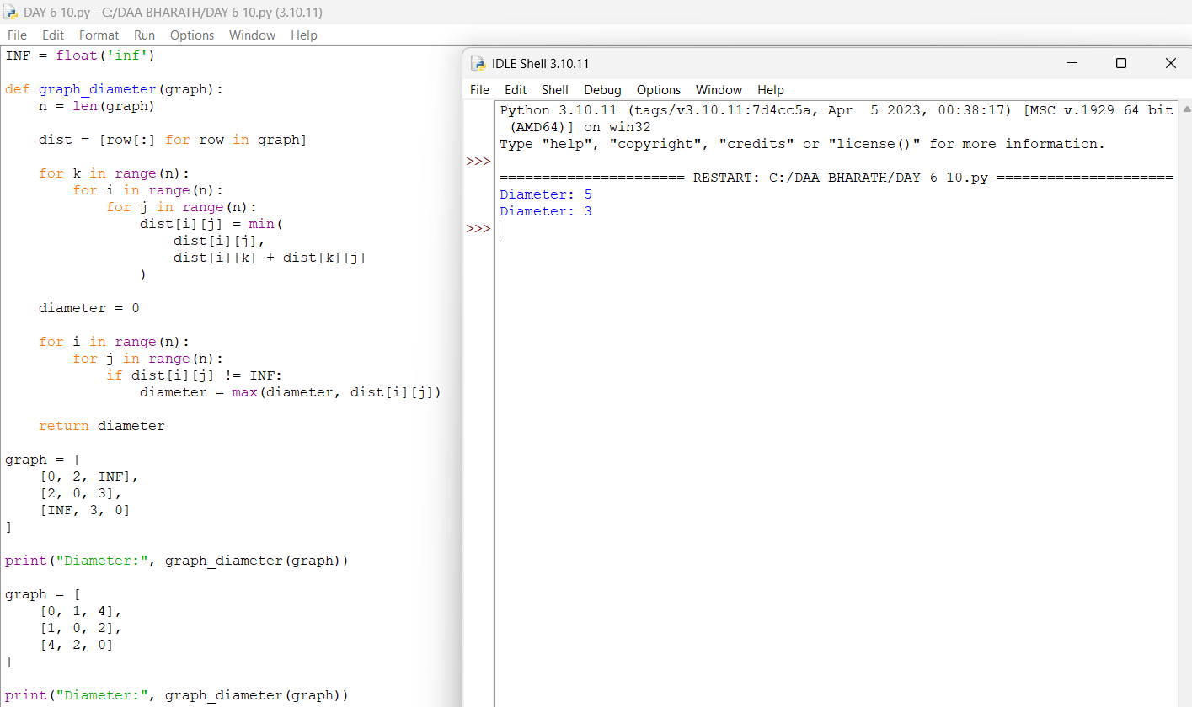

11. Find the Shortest Distance Between Two Vertices
Aim
To find the shortest distance between two given vertices in a weighted graph using the Floyd-Warshall Algorithm.
Algorithm
- Start the program.
- Initialize the distance matrix with the given graph.
- Consider each vertex as an intermediate vertex.
- Update the shortest distance between every pair of vertices using Floyd-Warshall.
- After completing the algorithm, access dist[u][v].
- Display the shortest distance between vertices u and v.
- Stop the program.

PROGRAM & OUTPUT
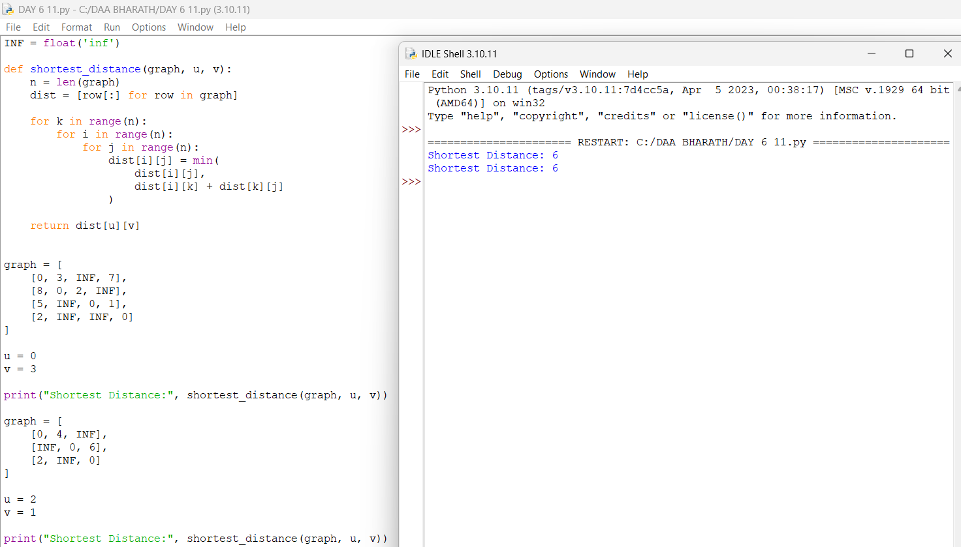

12. Find a Vertex Reachable from Every Other Vertex
Aim
To find the smallest indexed vertex that is reachable from every other vertex in a directed graph using Warshall's Algorithm.
Algorithm
- Start the program.
- Initialize the reachability matrix using the given adjacency matrix.
- Apply Warshall's Algorithm to calculate the transitive closure.
- For each vertex j, check whether every other vertex can reach j.
- If reach[i][j] is true for all vertices i, select vertex j.
- Since vertices are checked from smallest to largest index, return the smallest valid vertex.
- If no such vertex exists, display -1.
- Stop the program.

PROGRAM & OUTPUT
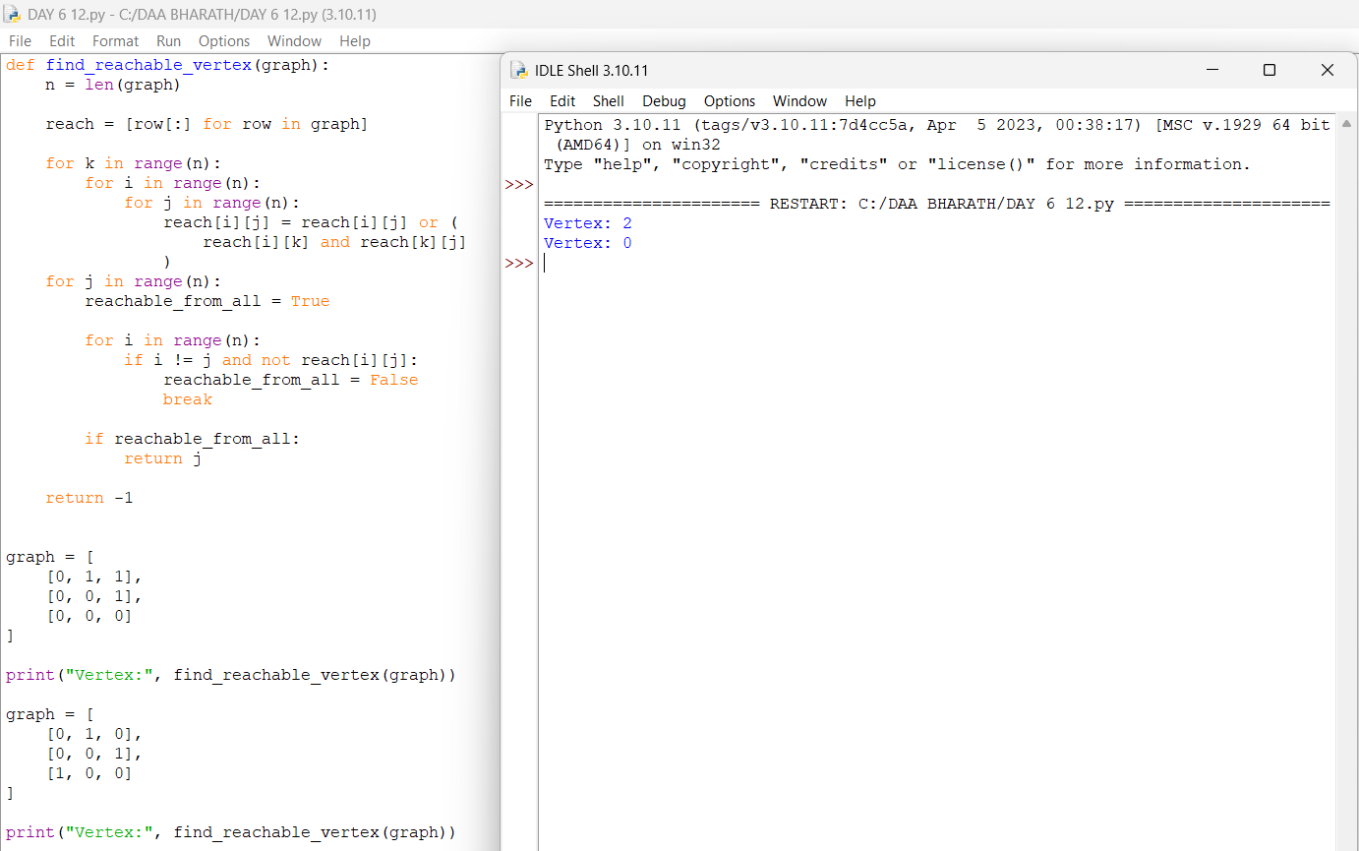

13. Find the Vertex with Maximum Reachability
Aim
To find the vertex that can reach the maximum number of other vertices in a directed graph using Warshall's Algorithm. If there is a tie, return the smallest indexed vertex.
Algorithm
- Start the program.
- Initialize the reachability matrix with the given adjacency matrix.
- Apply Warshall's Algorithm to find the transitive closure.
- For each vertex, count the number of other vertices it can reach.
- Compare the reachability counts of all vertices.
- Select the vertex with the maximum count.
- If there is a tie, select the smallest indexed vertex.
- Display the result.
- Stop the program
PROGRAM & OUTPUT
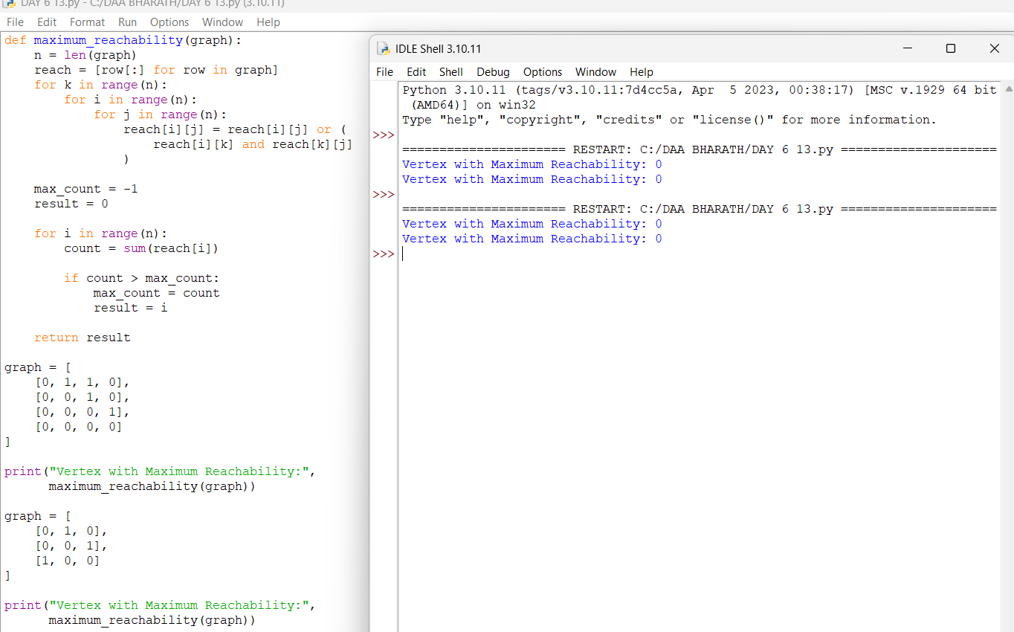

14. Find the Diameter of a Weighted Graph
Aim
To find the diameter of a weighted graph, which is the maximum shortest-path distance between any pair of vertices, using the Floyd-Warshall Algorithm.
Algorithm
- Start the program.
- Initialize the distance matrix using the given weighted graph.
- Consider each vertex as an intermediate vertex.
- Apply Floyd-Warshall to find the shortest distance between every pair of vertices.
- Find the maximum finite shortest-path distance.
- Display the maximum distance as the diameter.
- Stop the program.
PROGRFAM & OUTPUT
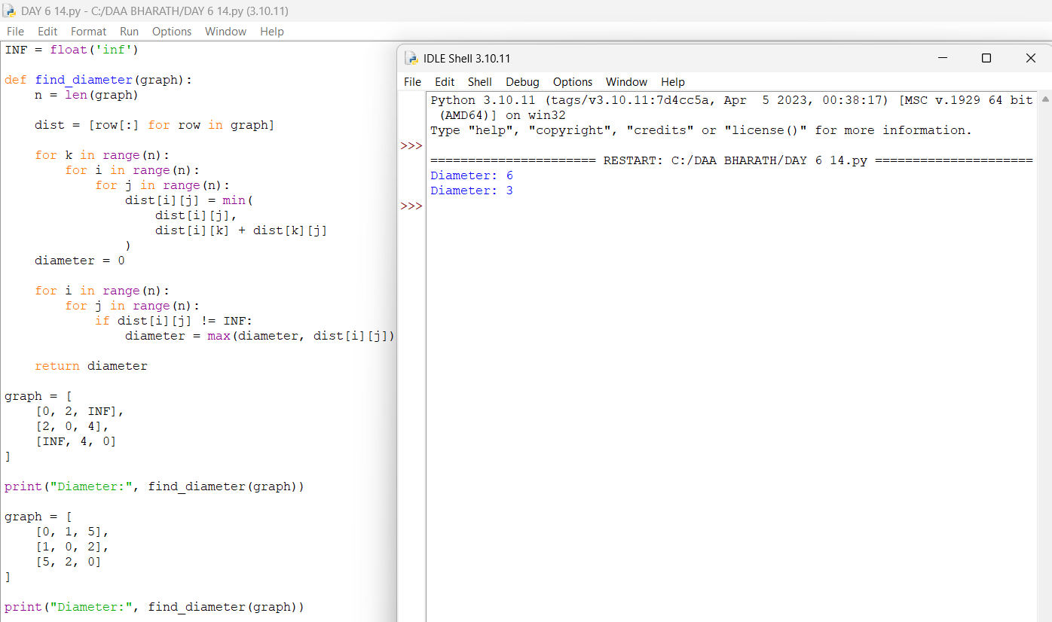

15. Check Whether a Graph is Strongly Connected
Aim
To determine whether every vertex in a directed graph is reachable from every other vertex using Warshall's Algorithm.
Algorithm
- Start the program.
- Initialize the reachability matrix with the adjacency matrix.
- Apply Warshall's Algorithm to calculate the transitive closure.
- Check whether every vertex can reach every other vertex.
- If all pairs are reachable, print Strongly Connected.
- Otherwise, print Not Strongly Connected.
- Stop the program.
PROGRAM & OUTPUT
